WorkAbilities Apparel Order Form EMBROIDERED
Total Order $________
Name__________________________________
Size | Color | Quantity
Sweatshirt with Full-front logo
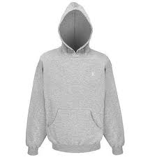
Hooded $42.00
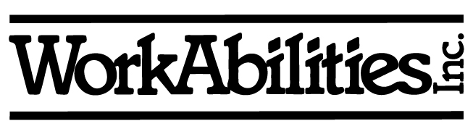
Hooded w/Ties/laces $52.00
Crew (no hood) $38.00
(B) Black (W) White (G) Grey
Size (S) Small (M) Medium (L) Large (XL) Extra large (XX-3XL)
Name________________________Placement______________(ADD $5.00)
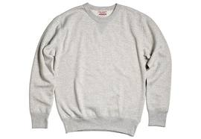
Sweatshirt with left crest logo
Size | Color | Quantity
Hooded $26.50
Crew (no hood) $22.50
(B) Black (W) White (G) Grey
Size (S) Small (M) Medium (L) Large (XL) Extra large (XX-3XL)
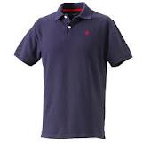
Name_______________________Placement______________(ADD $5.00)
Polo shirt with left crest logo (These run big!)
Size | Color | Quantity
60/40 Cotton $22.50 (these run big)
DryFit Mens Polo $32.00
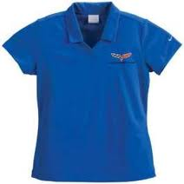
Size (S) Small (M) Medium (L) Large (XL) Extra large (XX-3XL)
Name________________________Placement______________(ADD $5.00)
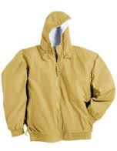
Hooded Lightweight Jacket with left crest logo
Size | Color | Quantity
(B) Black (G) Grey
$56.00 – Left Crest $76.00 – Full Back
Size (S) Small (M) Medium (L) Large (XL) Extra large (XX-3XL)
Name________________________Placement______________(ADD $5.00)
**COLOR OF LOGO WILL BE TEAL** ADD $2 for XX and $3 XXX Sizes

